**Get started with ASP.NET Core MVC**

* Create a web app.
* Add and scaffold a model.
* Work with a database.
* Add search and validation.

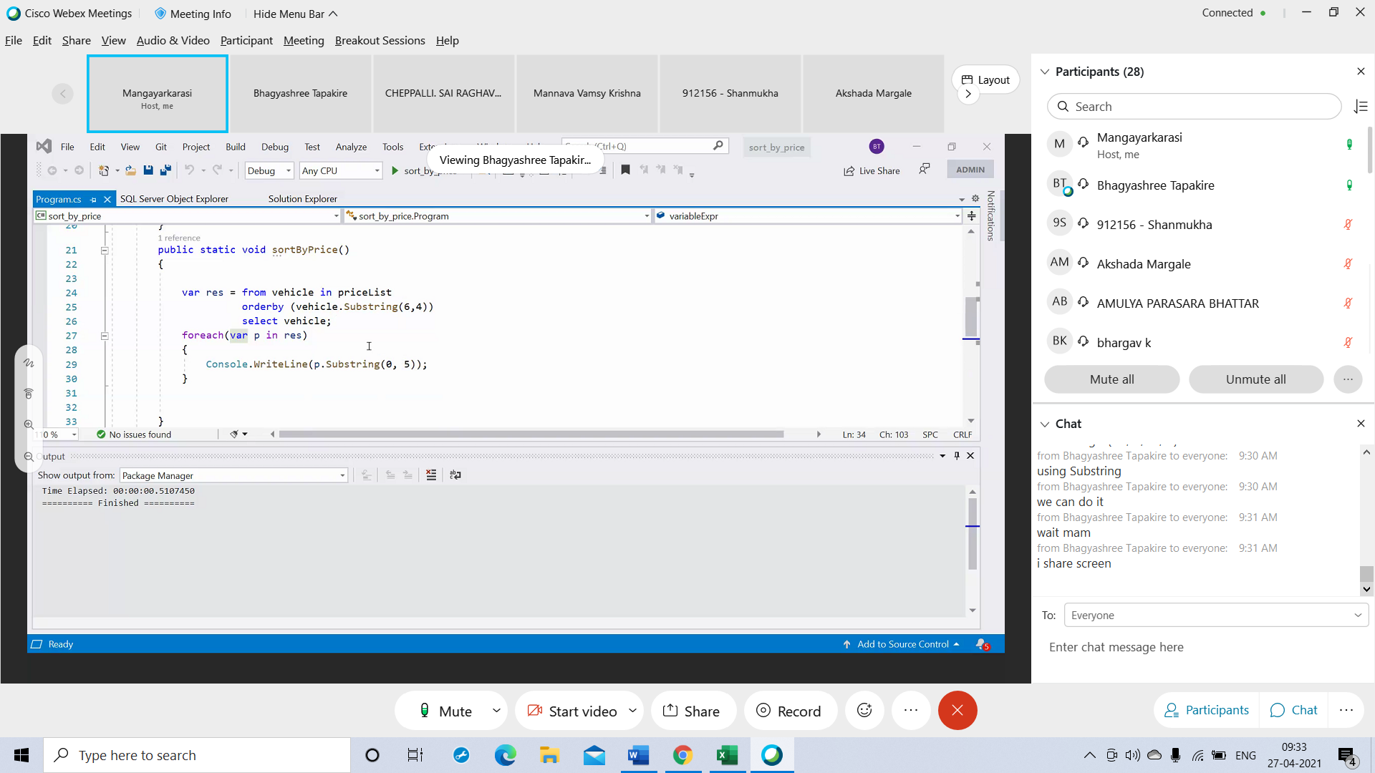

public static void sortByPrice() { var res = from vehicle in priceList orderby (vehicle.Substring(6,4)) select vehicle; foreach(var p in res) { Console.WriteLine(p.Substring(0, 5)); } }